CLOUD COMPUTING
SUBMITTED BY: ARMEEN ABID (BSE-011)
SUBMITTED TO: ENGR.MUHAMMAD SHOAIB
LAB 07
TASK 1:
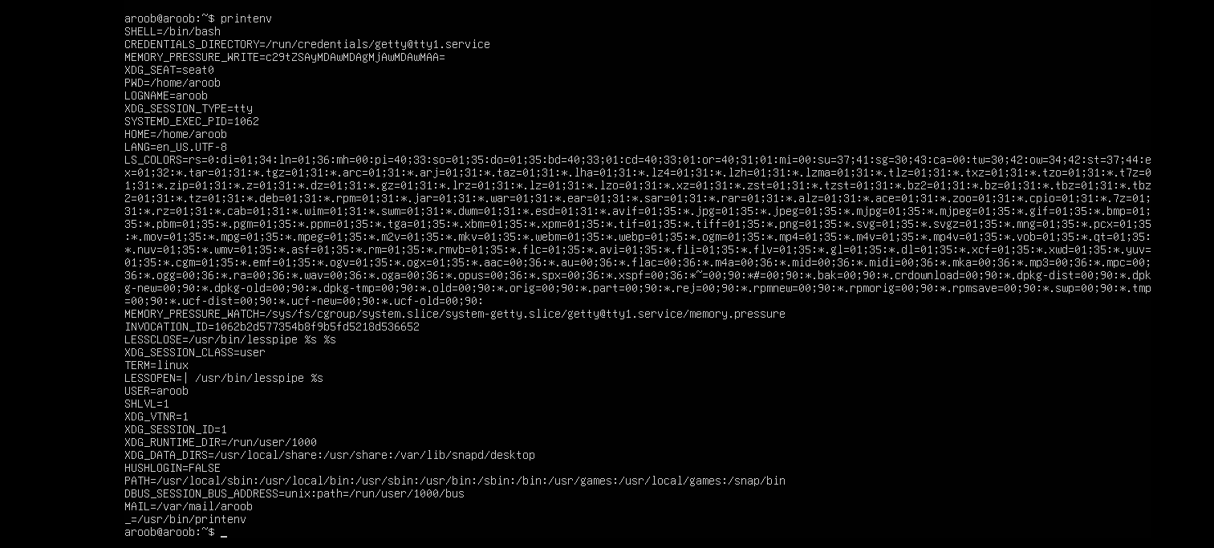
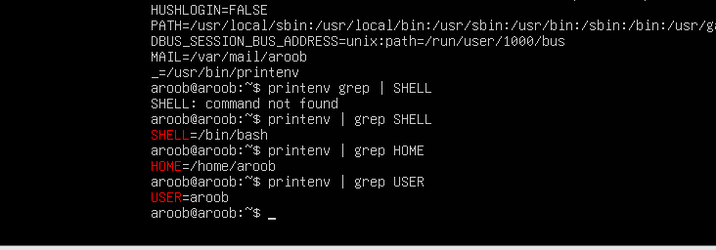
TASK 2:

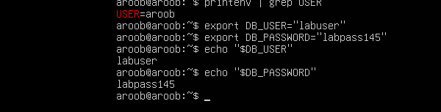

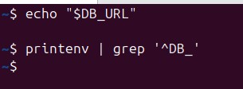
TASK 3:
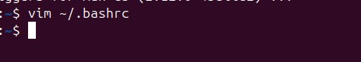

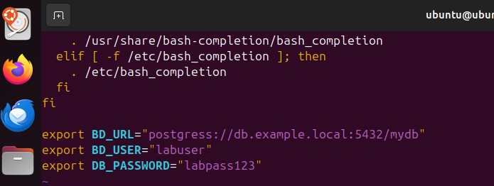

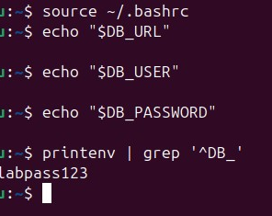
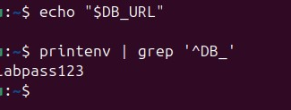
TASK 4:
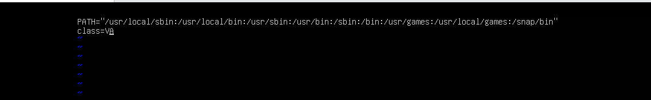
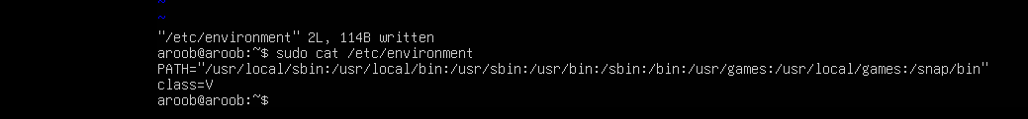
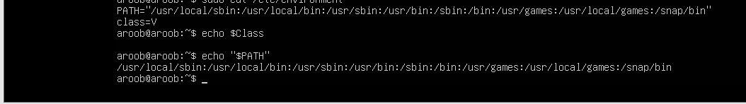
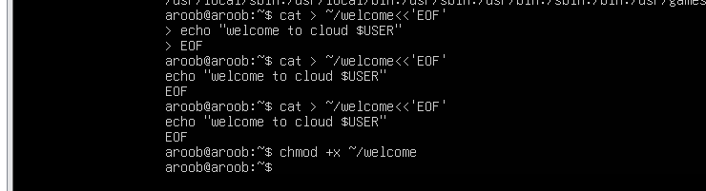
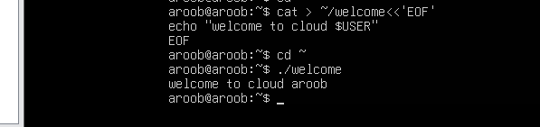
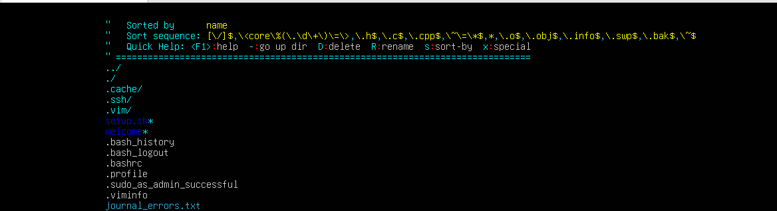
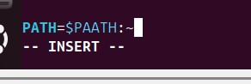

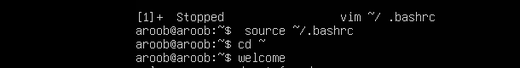
TASK 5:

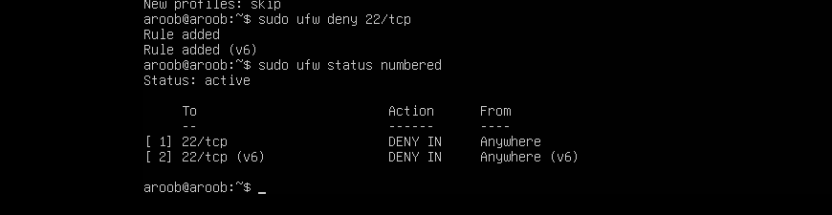
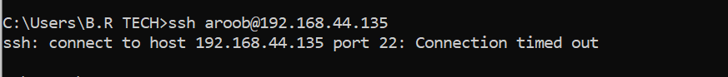
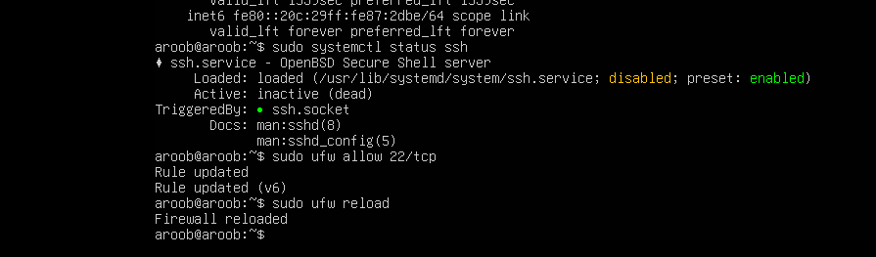
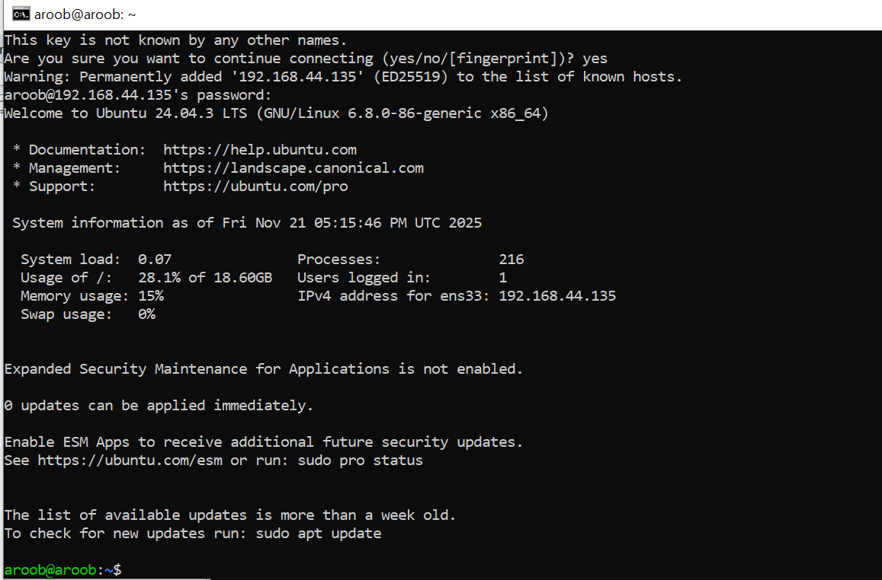
TASK 6:
